Name and Surname[1], Name and Surname [2], Name and Surname [3]

**Title of the work no longer than three lines**

**Title of the work no longer than three lines**

**Title of the work no longer than three lines**

The thesis should be written only in the "docx" format under the name "Surname_name.docx" (the file size cannot exceed 5 MB). In the case of several authors of the work (**up to three authors),** the file should be named with the surname and first name of the first author. The work should be sent to **article.sd@polsl.pl**. The body of the e-mail should include: "InterTechDoc2025 Publication Name and surname of the first author". Poorly formatted works and submitted not in accordance with the recommendations and on a date other than specified by the Organizer will not be accepted for further processing.

The volume of the work should be at least 0.55 of the publishing sheets, i.e. have 22,000 characters with spaces or contain drawings with a total area of 1650 cm2. The drawings also include tables and formulas, the area of which should be estimated each time.

**PUBLISHING GUIDELINES**

The thesis should be written in MS Word 2003 and later. The text of the work should meet the following requirements:

* column sizes for A4 format – standard margin of 2.5 cm on each side
* basic font Times New Roman 12 p.
* line spacing – multiple 1.3.
* paragraphs – 0.63 cm
* the text of the work and the captions under the figures must be justified (aligned to both edges)
* in the case of too large spacing between words, use manual division into syllables (do not hyphenate words in titles and subheadings)
* single letters, numbers and abbreviations must not be left at the end of the line (except for those appearing at the end of the sentence); to do this, move them to the next line by using the so-called hard space (pressing the key combination [Crtl], [Shift], [Space] directly between  
  a letter, number or abbreviation and the next word).

**Tables**

Text in tables - Times New Roman font size 12 p. Line spacing - single.

Tables should be avoided being divided between pages, but, if necessary, the continuation of the table should be abbreviated above the divided table (e.g. in Polish texts – table 1 cont., table 1 in English). Table titles should be written in the same font as the text font and centered. Table numbering should be continuous and aligned to the right (equal to the right edge of the table). A single line of the border and inside of the table should be used with a thickness of 1/2 p. Vertical arrangement of the tables  
is preferred, but if a horizontal arrangement is preferred, then the head of the table should be on the left side of the column (parallel to the left margin). In this case, the position of the page number remains unchanged.

If the table is borrowed from a publication, the source of the data should be given under it.

**Example. Table layout**

Table 1

Title on the axis of the table (font size 12 p.)

|  |  |  |
| --- | --- | --- |
| No. | Capitalized head | |
| Lowercase | Lowercase |
| With a capital letter |  |  |

Source: own study. (font 10 p.)

**Charts, diagrams, drawings, photos**

Objects embedded in the document, such as charts, drawings, and photos, should be **centered**. For schematics that consist of several objects, you should group them all. Objects inserted into the work should be legible.

Charts, diagrams, drawings and photos should be inserted without borders, except for maps. Before pasting, photos and drawings should be optimized (in graphics programs designed for this purpose) so that they are not too large. Raster graphics (scanned images) should be saved in one   
of the following formats: TIFF, BMP, JPEG or EPS. The optimal resolution for color and black-and-white photographs is 300 dpi, while for line drawings – max. 600 dpi.

Captions should be placed under the object, aligned to the left margin, folded in the typeface of the main text, but in a font two levels smaller (10 points), with a single line spacing. Extended captions, consisting of the main caption and explanations of drawing details, should be as wide as the column width.

**Example. Caption under the drawing**

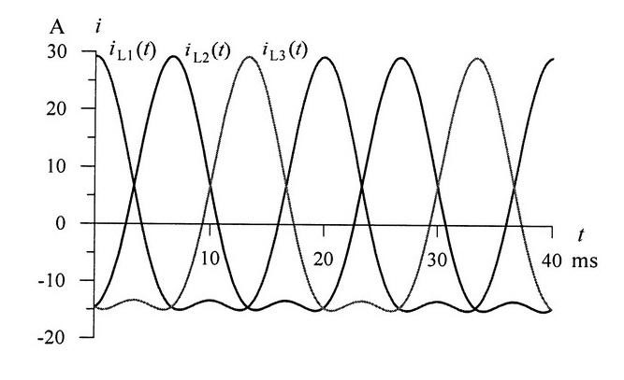

Fig. 2.7. Phase current waveforms after symmetrization

Source: Dębowski K.: The use of fuzzy sets in the description and optimization of energy properties as an extension and generalization of classical methods. Publishing House of the Silesian University of Technology, Gliwice 2011.

**Bibliography**

Bibliography - font of the same typeface and size as the main text. The bibliography should be prepared in the same way as footnotes, with the difference, however, that the author's surname should be placed first, and only then the first letter of the name or names. Reference to the bibliography in the text – e.g. [1].

**Example. Bibliographic record**

1. Acocella N.: Principles of economic policy. PWN, Warsaw 2002.
2. Antczak Z.: Departures of employees from the organization, [in:] Listwan T. (ed.): Human Resources Management. C.H. Beck Publishing House, Warsaw 2006.

**On the last page of the publication, it should be placed.**

Title in English

Keywords: up to five concepts

Abstract:

1. Name.Surname@polsl.pl, Scientific unit, Faculty, University, http://strona.polsl.pl/
2. Name.Surname @polsl.pl, Scientific unit, Faculty, University, http://strona.polsl.pl/
3. Name.Surname @polsl.pl, Scientific unit, Faculty, University, http://strona.polsl.pl/